2G

📶 What Is 2G (Second Generation Mobile Network)?
# Source: Chatgpt (GPT-5-Mini) at [1/23/2026]
2G, or Second Generation mobile network, was the first digital mobile communication system, introduced in the early 1990s. It replaced 1G’s analog voice with digital voice, bringing clearer calls, text messaging (SMS), better security, and SIM cards.
📲 2G is where mobile phones became truly mobile, secure, and could send texts for the first time.

🧩 Key Features of 2G:
# Source: Chatgpt (GPT-5-Mini) at [1/23/2026]
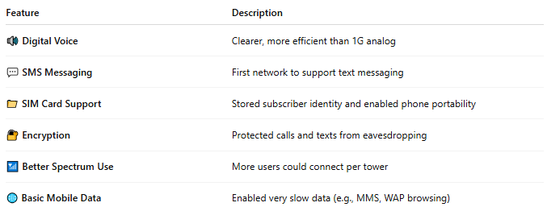

Feature | Description
🔊 Digital Voice | Clearer, more efficient than 1G analog
💬 SMS Messaging | First network to support text messaging
📁 SIM Card Support | Stored subscriber identity and enabled phone portability
🔐 Encryption | Protected calls and texts from eavesdropping
📶 Better Spectrum Use | More users could connect per tower
🌐 Basic Mobile Data | Enabled very slow data (e.g., MMS, WAP browsing)

🛰️ Technologies Used in 2G:
# Source: Chatgpt (GPT-5-Mini) at [1/23/2026]
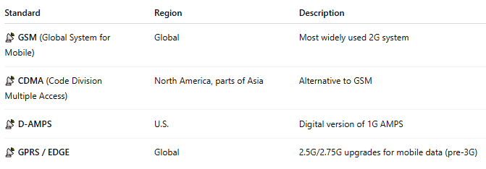

Standard | Region | Description
📡 GSM (Global System for Mobile) | Global | Most widely used 2G system
📡 CDMA (Code Division Multiple Access) | North America, parts of Asia | Alternative to GSM
📡 D-AMPS | U.S. | Digital version of 1G AMPS
📡 GPRS / EDGE | Global | 2.5G/2.75G upgrades for mobile data (pre-3G)

🔋 Benefits of 2G:
# Source: Chatgpt (GPT-5-Mini) at [1/23/2026]
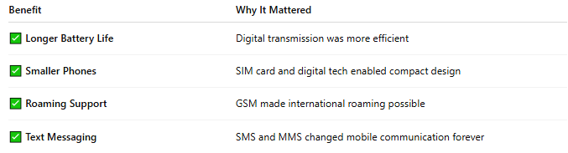

Benefit | Why It Mattered
✅ Longer Battery Life | Digital transmission was more efficient
✅ Smaller Phones | SIM card and digital tech enabled compact design
✅ Roaming Support | GSM made international roaming possible
✅ Text Messaging | SMS and MMS changed mobile communication forever

📉 Limitations of 2G:
# Source: Chatgpt (GPT-5-Mini) at [1/23/2026]
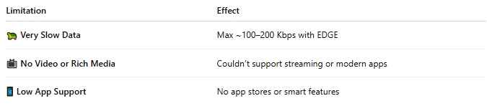

Limitation | Effect
🐢 Very Slow Data | Max ~100–200 Kbps with EDGE
📺 No Video or Rich Media | Couldn’t support streaming or modern apps
📱 Low App Support | No app stores or smart features

🕰️ Timeline:
# Source: Chatgpt (GPT-5-Mini) at [1/23/2026]
- 🟢 GSM launched: 1991 (Finland)
- 🔄 2.5G (GPRS): Early 2000s — allowed basic internet use
- 🔼 2.75G (EDGE): Improved speed slightly before 3G arrived

📖 Summary:
# Source: Chatgpt (GPT-5-Mini) at [1/23/2026]
| ✅ 2G brought the digital revolution to mobile phones — voice, text, SIM cards, and basic data.
| 🔄 It was the bridge between voice-only (1G) and internet-capable (3G+) generations.

